Face access control attendance System V2.0
----Instructions
2020-03-24
Preface
Thank you for purchasing and using our products. If you have any doubts or needs, please feel free to contact us.

Safety Precautions
 Notice
- Please understand you are responsible for properly configure all passwords and complete security settings of other related systems. In addition, properly keep your user name and password.
- The face recognition system mentioned in the article refers to the face access control attendance system.
- The document may be updated in a timely manner. Please refer to the actual system.

Update log

Update time | Update content | Update remarks
2019-10-28 | First edition
2020-3-24 | - parameter setting of temperature measurement terminal in equipment management  - Add identification temperature display in identification record

Contents
Update log 4
Chapter 1 System Overview 6
1.1 System Introduction 6
1.2 System Functions 6
1.3 System Networking 8
Chapter 2 Software Environment 9
2.1 Operating Environment 9
2.2 Use Precautions 9
Chapter 3 Main Operations 10
3.1 Main Operation Process 10
Chapter 4 Basic Operations 12
4.1 Creating a Database 12
4.2 System Login 13
4.3 Main UI 14
4.4 Visitor Registration 16
4.5 Setting the Reasons for Visiting 18
4.6 Equipment Management 18
4.7 Whitelist Management 28
4.8 Blacklist management 32
4.9 Statistics Query 33
4.9.1 Querying a Historical Record 33
4.9.2 Querying Visitor Registration 35
4.9.3 Attendance Statistics Query 36
4.9.4 System Log 36
4.10 Attendance Management 37
4.10.1 Setting an Attendance Rule 37
4.10.2 Holiday Settings 38
4.10.3 Leave Management 38
4.10.4 Sign-in Settings 39
4.10.5 Regular Class Settings 40
4.11 Area Management 40
4.11.1 Area Settings 40
4.11.2 Area Control Card Settings 41
4.11.3 Area Device Management 42
4.11.4 LED Screen Settings 42
4.12 System Management 45
4.12.1 System Settings 45
4.12.2 Database Configuration 46
4.12.3 Department Management 47
4.12.4 Operator Management 47
4.12.5 Operator Authorization Group 51
4.13 User Switching 52
4.14 About the System 52
Appendix 53
Appendix 1: Multi-Client Access 53
Appendix 2: Face Recognition Management System Installation 55
Appendix 3: Database Installation 58
Appendix 4: Mandatory Software Installation for the Face Recognition Management System 58
Appendix 5: Software installation 58
Appendix 6: Software Uninstallation 60

Chapter 1 System Overview

System Introduction
As a background face recognition terminal management system, the face recognition management system provides the following functions:
- Remotely deliver lists to face recognition terminals.
- Modify equipment parameters.
- Remotely open doors.
- Receive passer identification records from face recognition terminals.
In addition, the face recognition management system rapidly manages face recognition terminals in batches and performs remote configurations and operations by means of its powerful equipment management, list management, attendance management, and work site management functions.

System Functions
This section describes functions of the face recognition management system, helping you better understand this system.
- Real-time monitoring
The system displays equipment comparison records, images, and information on the main screen in real time.
- Visitor registration
The system registers visitor information and delivers the visitor information to equipment for face recognition.
- Remote door opening
The system remotely controls face recognition terminals to open doors.
- Equipment management
Equipment can be added to or removed from the face recognition management system, so that you can modify equipment parameters in the system.
- Whitelist registration
The system registers whitelisted visitors and delivers the whitelisted visitor information to equipment for face recognition, so that whitelisted visitors can pass through doors through face recognition.
- Whitelist management
The system manages whitelist data in different groups. You can add, modify, or delete whitelisted visitors and batch import or export whitelist data.
- List synchronization
The system supports manual list synchronization with face recognition terminals.
- Blacklist management
You can add, modify, or delete blacklisted visitors and batch import or export blacklist data.
- Blacklist warning
The system generates real-time warnings based on front-end blacklist comparison.
- Historical data management
The system supports historical record search and comparison by user-defined conditions.
- Configuration of reasons for visiting
You can configure reasons for visiting according to actual application scenarios.
- Attendance management
The system supports customized attendance rules for attendance measurement.
- Work site management
The system can manage LED screens and areas of equipment. It measures visitors through LED screens in different areas.
- Operator management
You can add, modify, or delete system operators.
- Permission management
The system assigns different permissions to different operators. The system administrator can set different operator permission groups.
- Log management
The system provides operation logs of operators.

System Networking
The system directly connects to face recognition terminals through switches. The following figure shows the networking architecture.
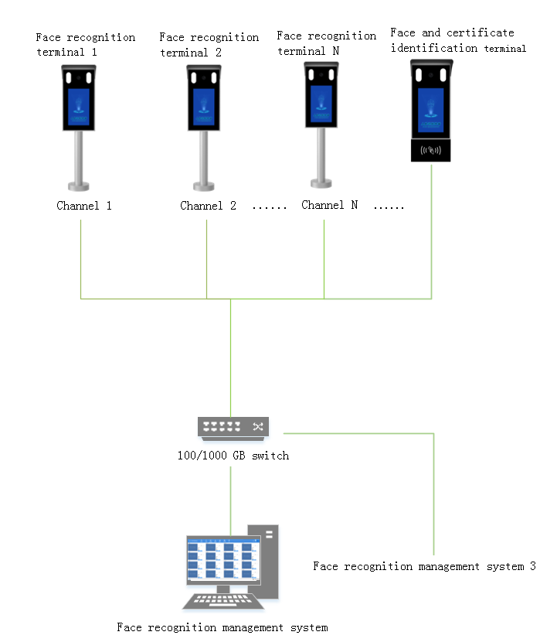

Chapter 2 Software Environment

Operating Environment
- Computer configuration: Intel I3 or higher processor, 4 GB memory, and 500 GB or higher hard disks
- Resolution: 1920*1080 or higher
- OS: Windows XP SP3, Windows 7, and Windows 10 flagship versions
- Operating environment: Framework 4.0 Client or later
- Database: SQL Server 2005, SQL Server 2008 (recommended), SQL Server 2012, and MySQL

Use Precautions
Face recognition equipment must be installed when using this system for the first time.

Chapter 3 Main Operations

Main Operation Process
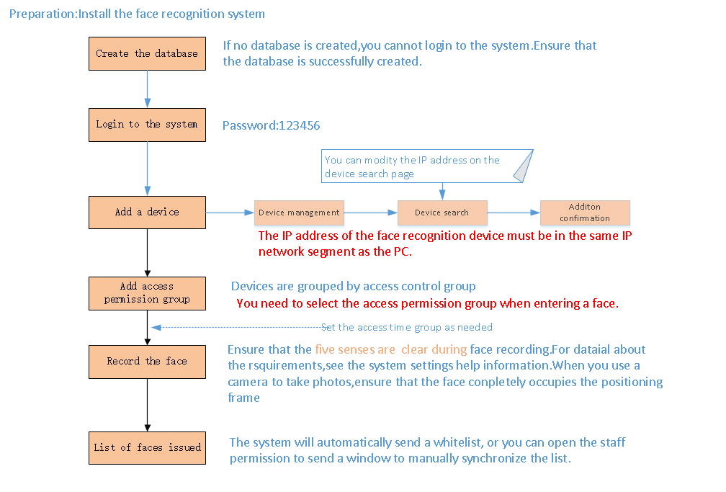
1. Create a database. For details about how to create a database, see section 4.1 "Creating a Database."
2. Add equipment, as shown in the following figure.
To modify an IP address, click the IP address and modify it, and then click ENTER.
When adding equipment, you must set the IP address of the equipment in the network segment that is consistent with the local PC to ensure normal communication.
3. Recording the face
Imaging varies with USB cameras. Logitech C270i or C920 cameras are recommended.
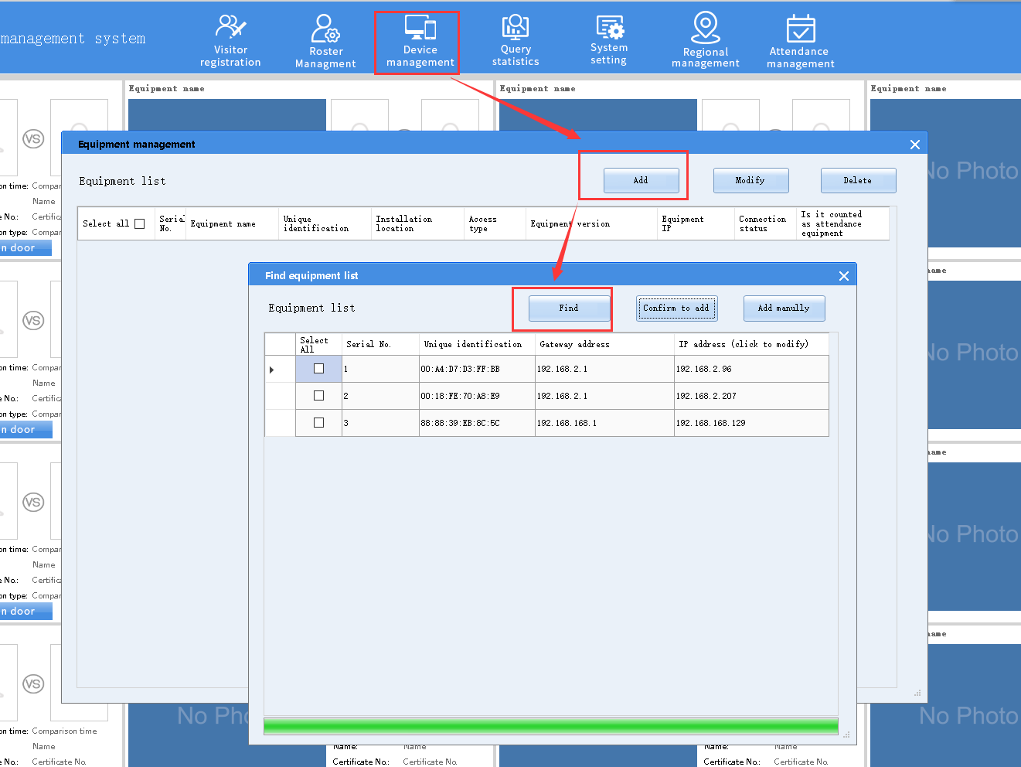
When recording a face, take a photo or select a local photo. For details about the photo taking requirements, see the sample photos.
After a face is recorded, select the white list and the target equipment, and click Update whitelist.

Chapter 4 describes detailed system operations.

Chapter 4 Basic Operations

Creating a Database
1. To create a SQL Server database, select . Enter Server name, Database name, Connect username, and Connect password. Click Connect test.
If the database is not installed for the first time, click Database upgrade to upgrade the database.
2. To create a MySQL database, select Install database (if not installed) for the first time. The system takes about 10s to create the MySQL database. After the database creation is completed, click Save settings.
If the system already has a MySQL database, deselect Install database (if not installed). Enter the database connection password and log in to the created database.
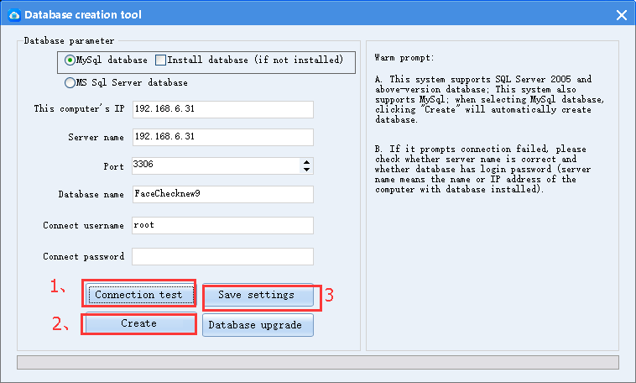

Step 1 tips
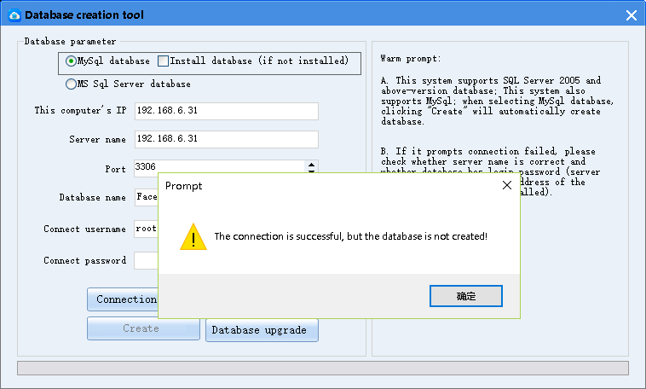
Step 2tips
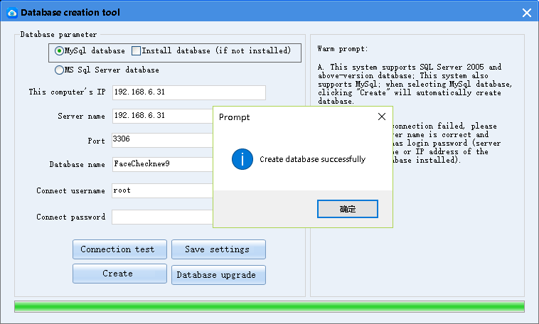
Step 3ips

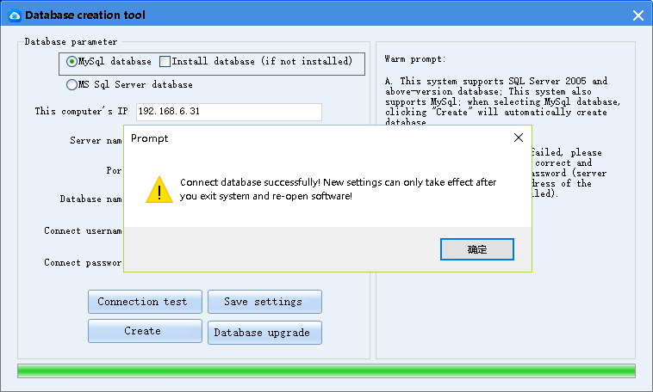

System Login
Step 1: Double-click 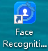 on the desktop or choose Start > All Programs > Face Recognition Management System, and click the application icon in the Face Recognition Management System folder to log in to the system, as shown in the following figure.
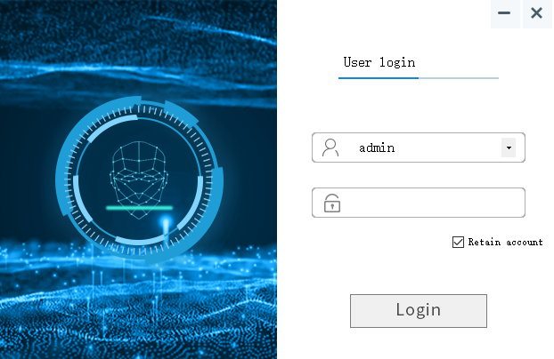
Step 2: Enter the account name and password, and click Login.
- Account name: admin (default)
- Password: 123456
If you select Retain account, the system remembers the login account and you do not need to enter the account name for subsequence logins.
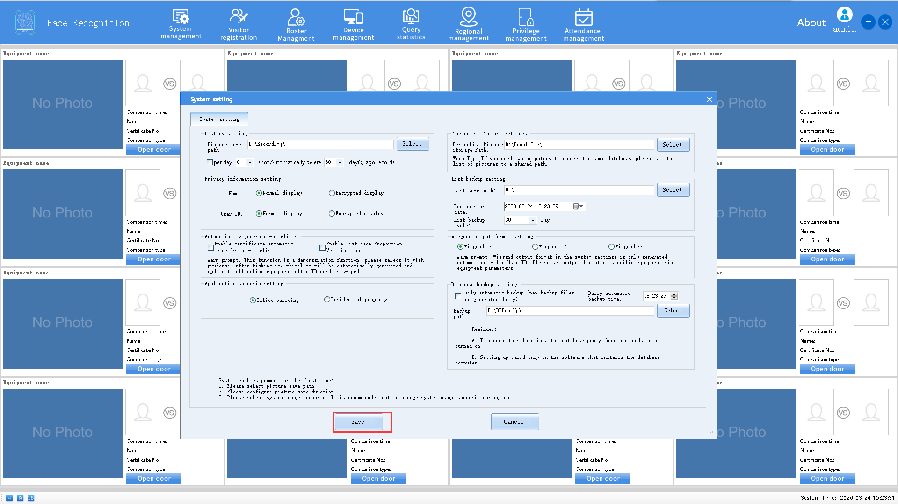
After entering for the first time, you need to select the list storage path and save it, Pictured above.
After you successfully log in to the system, configure the parameters as described in section 4.12 "System Management."

 Note
- Account name: admin (default)
- Password: 123456
Please properly keep the password after it is changed. Otherwise, you may be unable to log in to the system.

Main UI
- Main UI
After login, the main UI is displayed. By default, 16 channels of real-time monitoring screens are displayed, as shown in the following figure.
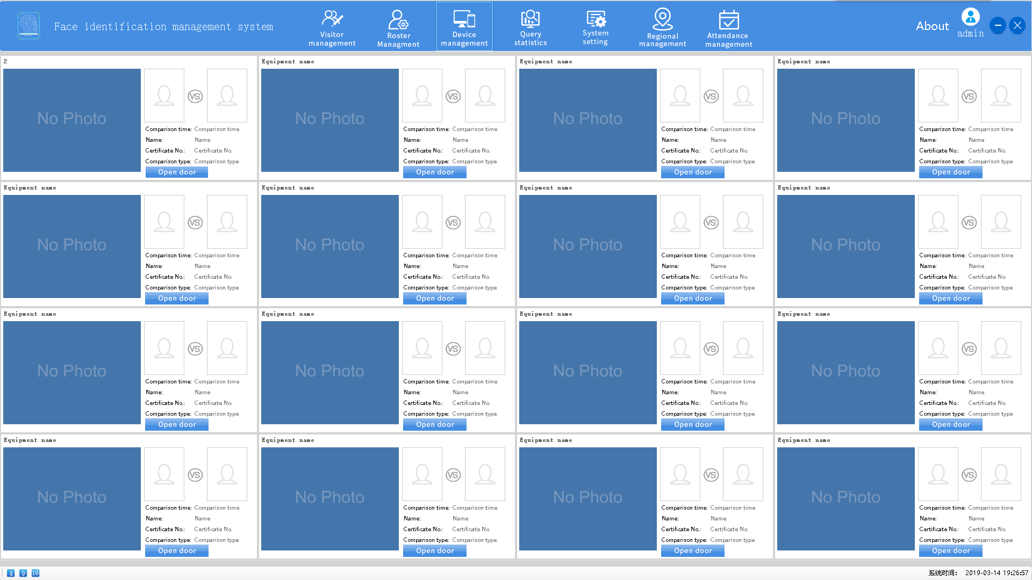
- Door opening
When you click Open door, the system remotely sends the door opening instruction to a face recognition terminal.
- Real-time monitoring data
The real-time monitoring data UI displays the panoramic photo for comparison (area 1), captured photo (area 2), and template photo (area 3), comparison result above the Open door button, including the identity card information and comparison time, as shown in the following figure.
1
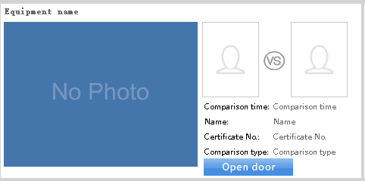
2
3

- Split-screen monitoring
The lower left corner of the main UI displays 4, 9, and 16, indicating the 4-pane, 9-pane, and 16-pane real-time monitoring screens displayed on the main UI.

Note
If the resolution of the computer display is lower than 1920*1080, the 16-pane screen will be incomplete. Therefore, select the 9-pane, 4-pane, or single-pane mode. The computer display with a resolution higher than 1920*1080 is recommended.

Visitor Registration
You can register visitors by priority. The visitor registration flow is as follows:

The following figure shows the visitor registration page.
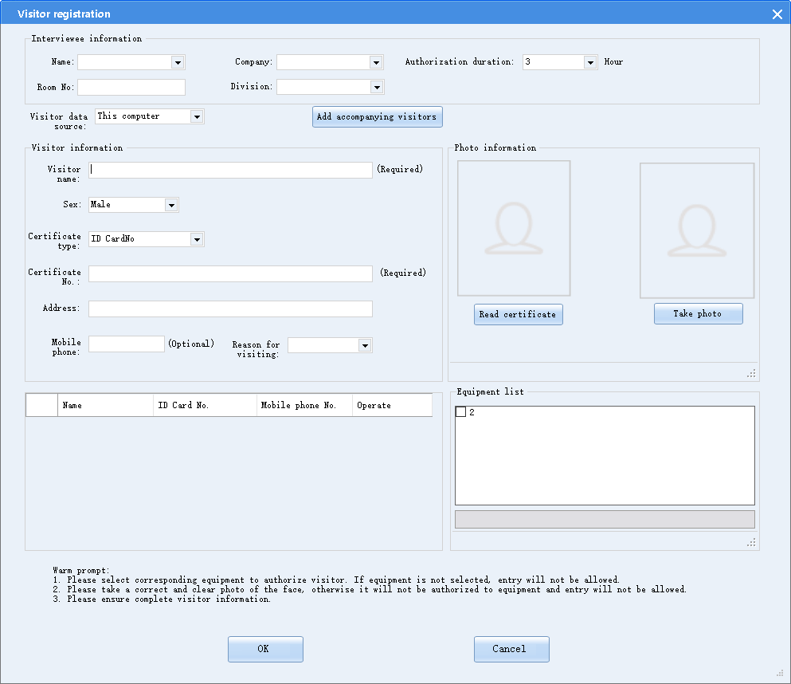
To register a visitor, perform the following steps:
Step 1: Enter the interviewee information or search for a visitor from the system, and set the authorization duration.
Step 2: The operator reads or registers visitor information in the system.
Step 3: Fill in the mobile number of the visitor.
Step 4: Select the reason for visiting.
Step 5: Take a photo of the visitor.
Step 6: Select equipment to deliver the visitor information.
Click Add accompanying visitors to add one or more accompanying visitors. When adding accompanying visitors, you only need to read visitor information instead of entering visitor information and specifying the equipment.

Note
1. Imaging varies with USB cameras. Logitech C270i or C920 cameras are recommended.
2. The certificate information can be read only when the identity card reader is connected to the system. If not, manually enter the visitor information or select the comparison information. The identity card reader shall adopt the USB interface standards. ZKTeco ID180 desktop identity card reader is recommended.

Setting the Reasons for Visiting
The following figure shows the Visitor Reason Settings page.
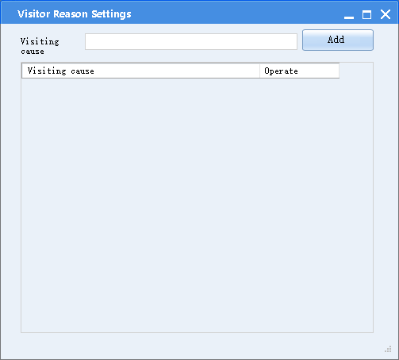
Set the reasons for visiting and save the settings.

Equipment Management
After adding a face recognition terminal to the system, you can set the equipment parameters.
- Adding the equipment
1. Automatic search
Choose Equipment Management > New > Find. The found face recognition terminals are displayed in a list. Modify the equipment IP address and gateway, and click Confirm to add.
When adding equipment, you must set the IP address of the equipment in the network segment that is consistent with the local PC to ensure normal communication.
Note: the password must be entered when adding equipment. The password is 888888
The following figure shows the equipment list.
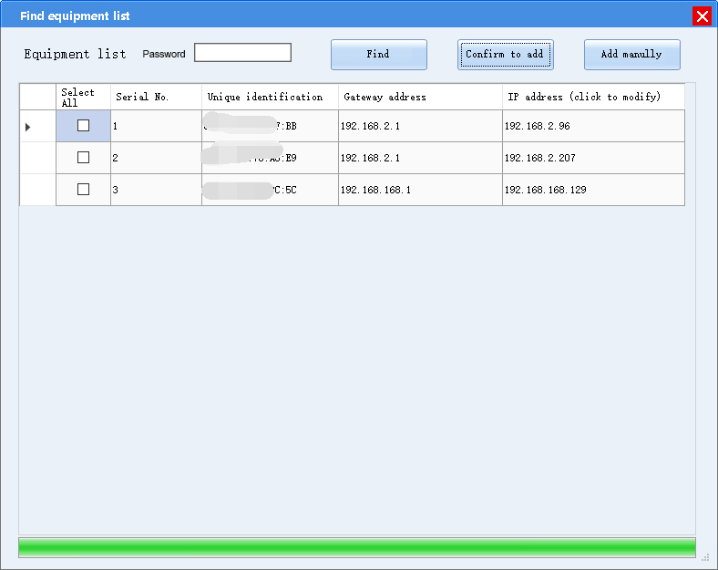
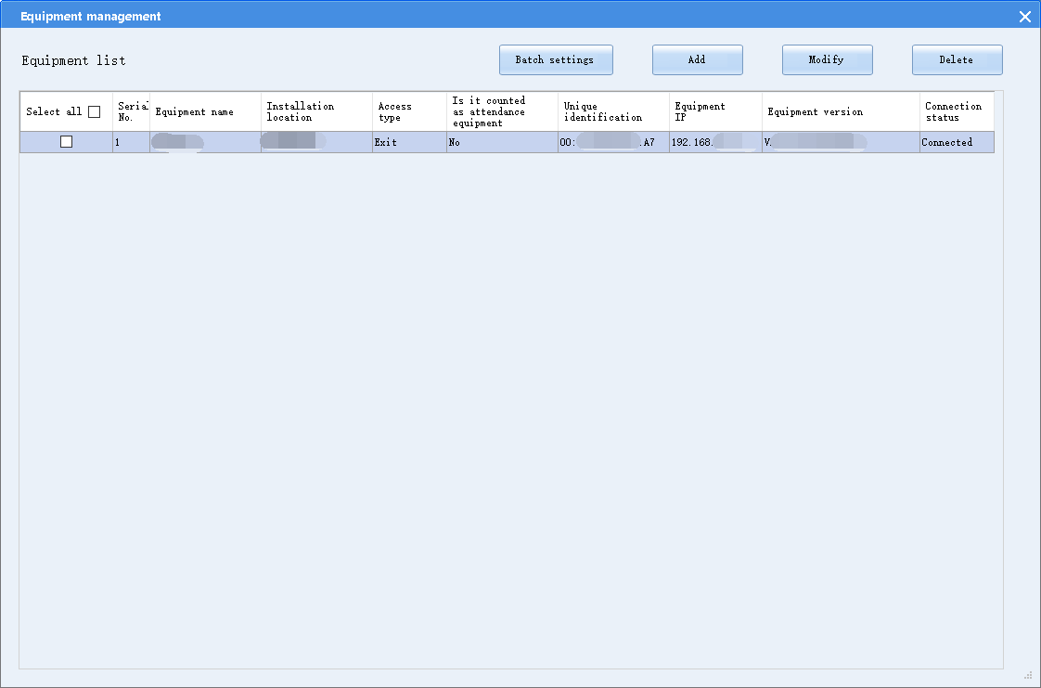
2. Manual adding
Choose Equipment Management > New > Add manually. Enter the equipment IP address to add the equipment.

- Modifying equipment parameters
After selecting the equipment, click Modify to display the equipment modification page. Modify parameters such as equipment name, installation position, access type, voice prompt for face detection, panoramic photo storage, photo monitoring, fill light type, panoramic photo upload, blacklist upload, and automatic data coverage.
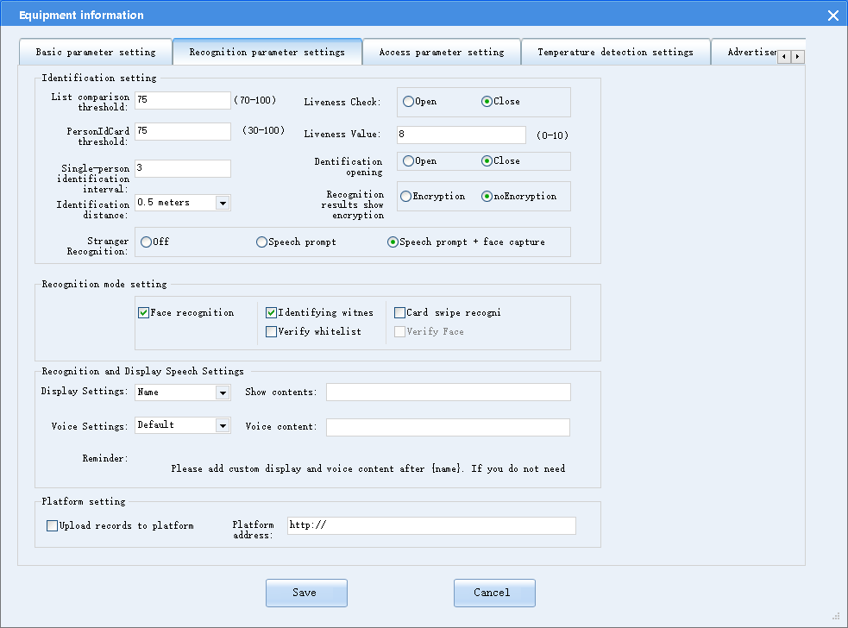
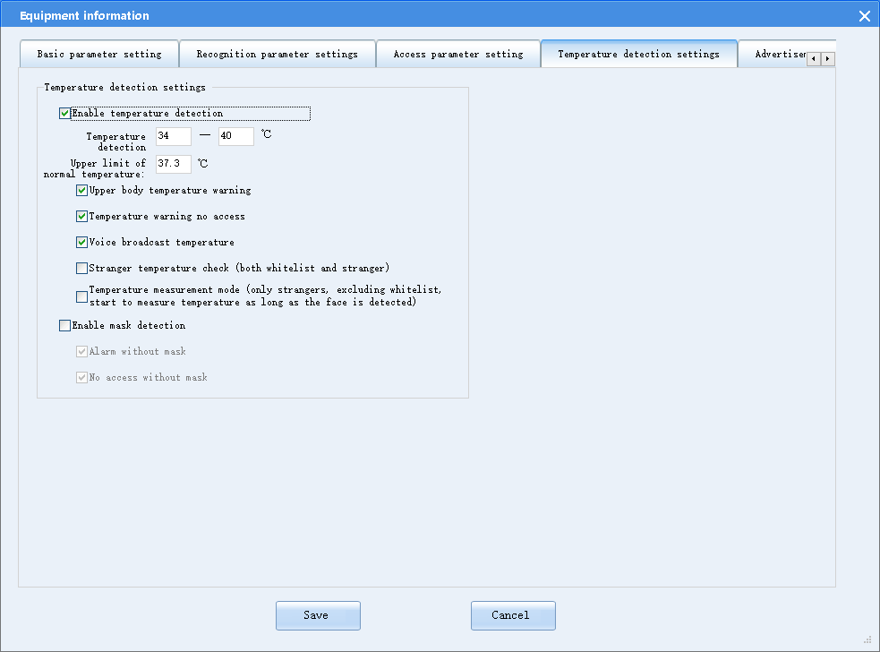
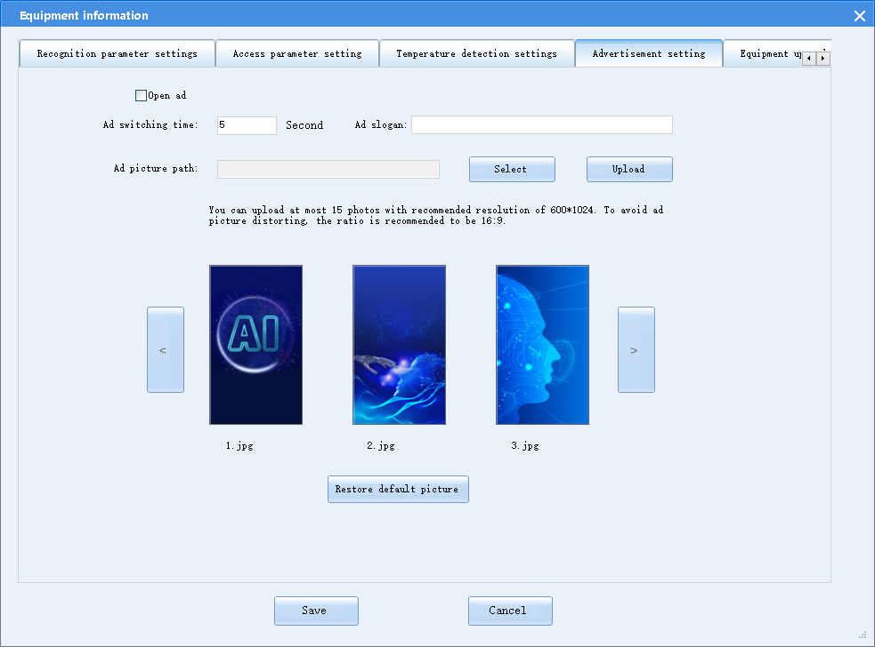
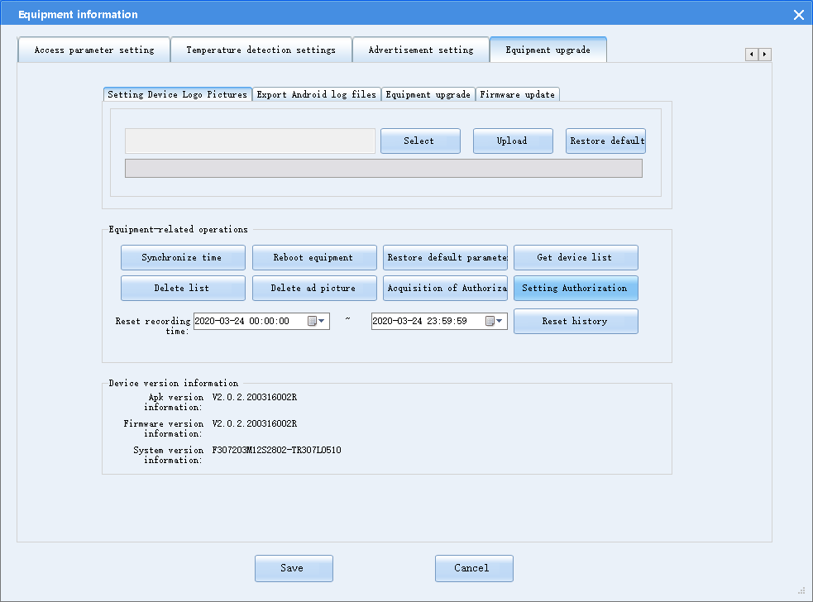

The parameters are as follows:
- Equipment name
Modify the equipment name. After modification, all saved historical data is marked with the equipment identifier. The equipment name should be modified before use. It is not recommended to modify the equipment name during use.
- Installation position
Modify the equipment installation position. After modification, all saved historical data is marked with the equipment installation position. The equipment installation position should be modified before use. It is not recommended to modify the equipment installation position during use.
- Access type
Modify the access type. After modification, all saved historical data is marked with the access type, facilitating record query and management.
- Blacklist management
Configure the blacklist record upload function according to actual requirements. After configuration, the face recognition terminal uploads blacklist comparison results to the client in real time. It is recommended to enable the blacklist record upload function.
- Panorama photo upload
Configure the panorama photo upload function according to actual requirements. After configuration, the face recognition terminal uploads all panorama photos in comparison records to the client in real time. It is recommended to enable the panorama photo upload function.
- Panorama photo compression quality
Set the compression quality of locally stored and uploaded panorama photos. The better the photo quality, the larger the occupied space.
- Local storage of panorama photos
After this function is enabled, panorama photos are saved locally. However, panorama photos can still be uploaded to the client.
- Fill light brightness
Drag the slider to adjust the fill light brightness.
- Access control password
Configure the access control password used to enter main page of the settings menu. After configuration, you can enter the main system settings page using this password.
- Automatic data coverage
Set the automatic data coverage limit. When the capacity reaches the limit, the system overwrites historical data.
- System volume
Drag the slider to adjust the volume of the face recognition equipment.
- Voice prompt for face detection
After this function is enabled, the system prompts that the face is unauthorized upon detecting a stranger.
After this function is disabled, the system does not generate any prompt upon detecting a stranger.
- List threshold
When the list threshold is low, it is easy to make comparisons during face recognition. When the list threshold is high, face recognition is more accurate, but the pass-through rate is lower. Therefore, set the list threshold according to the equipment prompts.
- Living detection
When living detection is enabled, the system judges the living state of the face to prevent photo or video attacks using mobile phones. After living detection is passed, the system recognizes the face. If living detection fails, the system prompts for non-living attacks.
When living detection is disabled, the system does not judge the living state of the face.
- Living threshold setting
When the living threshold is high, the living detection is strict, the accuracy is high, but the living detection duration is long. Therefore, set the threshold according to the equipment prompts.
- Single person recognition interval
Set the single person recognition interval for deduplication. The system does not compare the single person's face within the specified interval. The recommended value is 3s.
- Recognition distance
Configure the farthest distance for face recognition of the face recognition terminal. By default, the distance is not limited and can be set according to actual requirements.
- IC card recognition mode
Set the IC card comparison mode or IC card+face comparison mode.
In IC card comparison mode, the system reads IC card data in the system, takes photos, and opens the gate.
In IC card+face comparison mode, the system reads IC card data in the system, takes photos of the face and recognizes the face. If consistent, the system opens the gate.
- Door opening delay
When a door opening delay is configured, the system closes the door if nobody passes through the door within the specified time.
- Access control
The access control modes include common mode and access control mode. By default, the common mode is adopted.
Common mode: The face recognition equipment sends a door opening signal when the whitelist comparison and certificate comparison are successful.
Access control mode: The face recognition equipment sends a door opening signal only when the whitelist comparison is successful.
Wiegand output: The Wiegand output format includes Wiegand 26-bit, Wiegand 34-bit, and Wiegand 66-bit. The Wiegand output format upon door opening is subject to the settings.
- Fill light brightness settings
Drag the fill light brightness slider to configure the fill light brightness according to actual situations.
- Fill light control mode settings
Constant off: When you select this option, the fill light is constantly off.
Constant on: When you select this option, the fill light is constantly on.
Specified period: When you select this option and set the automatic fill light enabling period, the fill light turns on in the specified period. The fill light turns off in other periods.
Smart fill light: When you select this option, the fill light intelligently turns on or off according to the environment.
After configuration, click the Save button in the upper right corner to save the settings.
- Enable ads: When you select this option, the system displays ads.
- Ads switching time
Configure the ads switching time if ads contain multiple images.
- Ads slogan
Set the ads slogan displayed on the main screen of the face recognition terminal.
- Ads image
You can import ads images from the USB flash drive. To improve an ads image, copy the ads image to the USB flash drive, connect the USB flash drive to the equipment, click Import from the USB flash drive, and select the ads image. You can import up to 15 ads images. The recommended image scale and resolution are 16:9 and 1024*600 respectively.
- Restoration to default image
When you select this option, an imported ad image will be deleted. The ads form is restored to default factory settings.
- Time synchronization
When you select this option, the face recognition terminal synchronizes its time to the PC time.
- Restart
When you select this option, the system remotely restarts the face recognition terminal.
- List deletion
When you select this option, list data is deleted from the face recognition terminal.
- Platform settings
Enable the platform upload function in platform settings. Fill in the platform address according to the interconnected platform interface document. Then, the system sends the recognition and door opening data to the platform.
- Equipment deletion
Select the equipment from the equipment list and click Delete. The face recognition terminal is removed from the system.
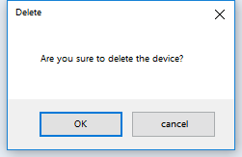

Note
Equipment parameters can be directly modified on the face recognition terminal. For details, see the face recognition terminal operation guide.

Whitelist Management
You can query, export, import, add, modify, and delete whitelist data via the whitelist management function.
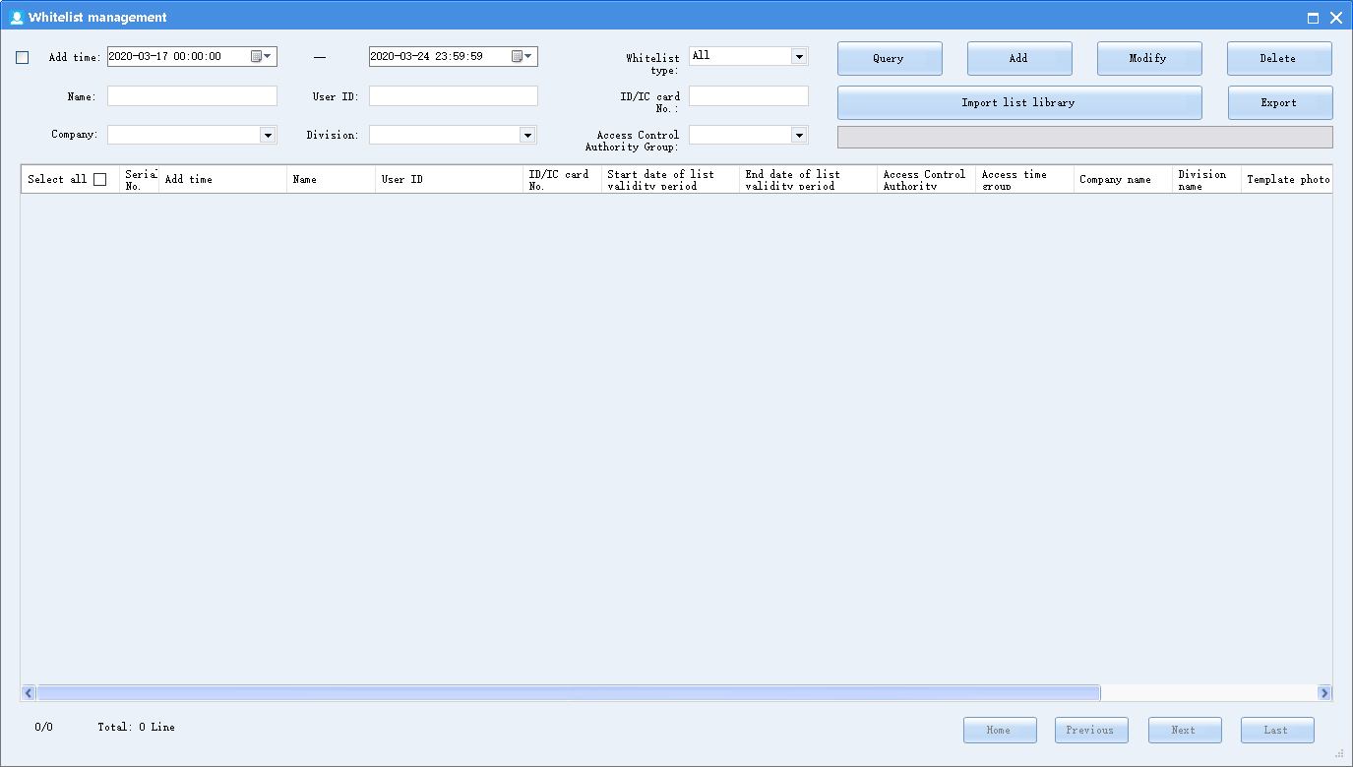
- Querying a whitelist
You can query a whitelist by adding time, name, identity card No., and other conditions.
To query a whitelist, select the start time and end time, enter the name or identity card No., and click Find.
- Adding a whitelist
You can add a whitelist to register whitelisted person's information.
To add a whitelist, click Add. Enter the name, sex, nationality, identity card No., ID/IC card No. (when Whether Autogeneration is selected, the system automatically generates the ID/IC card No.), address, list validity period, building (company), unit (company), and room No. Alternatively, directly read the person's information using the identity card reader. After the person's information is input, collect at least one photo. You can select a photo saved in the PC or take a clear front face photo using the PC camera (the PC needs to be connected to the USB camera). Then, click Save.
The following figure shows the page for adding a whitelist.
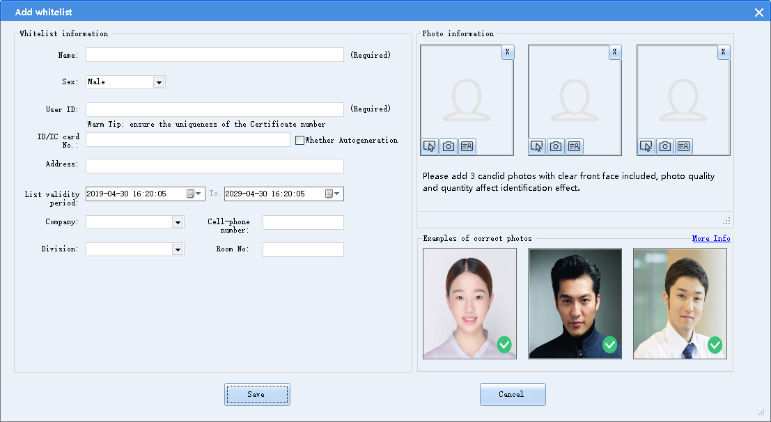
After the whitelist is added, select it and the equipment on the whitelist management page, and click the button for delivering the whitelist to the specified equipment.


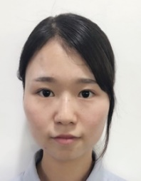

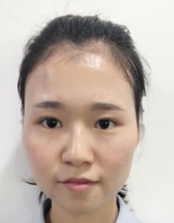
- Moderate light intensity on the face
- Uniform brightness on the face
Simple background
Sample registration photo
- Front face
- Normal expression
- Non-reflective lens
Add a registration photo
Photo requirements:
The photo imported from the client must be smaller than 5 MB.
The face area should be no less than 128×128 pixels.
Face size accounts for more than 1/3 of the entire photo.
Add registration photos according to the normal face forms in the scene where the equipment is located to improve the recognition accuracy. Up to 3 registration photos can be added.
Hair down
Glasses removed
With makeup
Bangs pulled up

 Photo requirements
- Modifying a whitelist
To modify a whitelist, select it and click Modify. It is prohibited to modify the identity card No. on the whitelist. After the equipment is removed from the equipment list on the whitelist modification page, the system automatically deletes the whitelist from the corresponding equipment.
The following figure shows the page for modifying a whitelist.

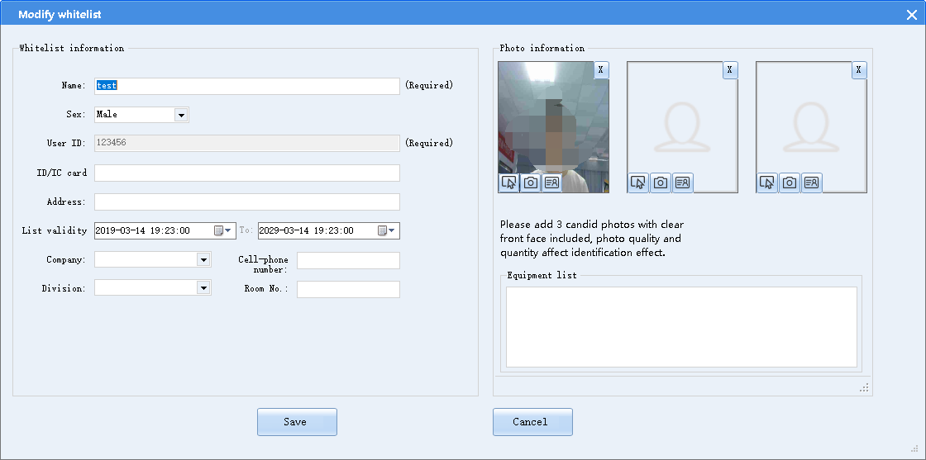
- Deleting a whitelist
To delete a whitelist, select it and click Delete.
- Exporting a whitelist
To export a whitelist after querying the data, select it and click Export. Select the path for saving the exported whitelist, as shown in the following figure.
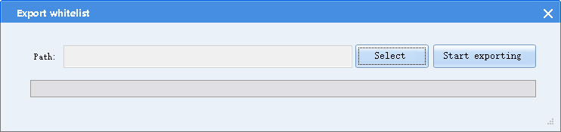
- Exporting the list library template
Before batch import, export the list library template to the PC. To export the list library template to the specified path, click Select catalogue, select the list template, and click Start importing.
- Importing the list library
Before batch import, export the list library template to the PC. After editing the list library template, copy the file path or click Select catalogue, select the whitelist template, and click Start importing.
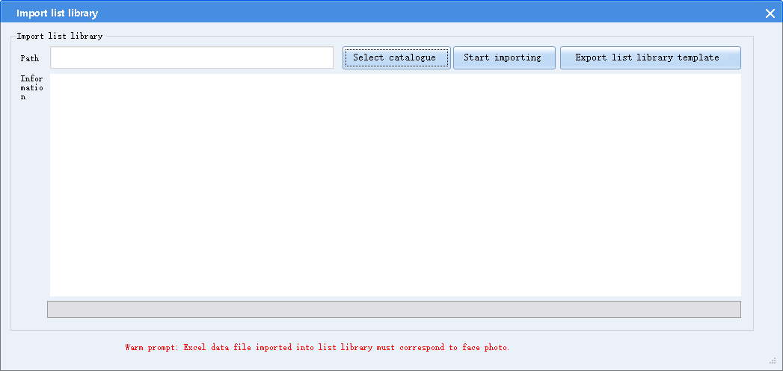
- Importing the prospective list
You can batch import identity card No. using the prospective list template. After importing the identity card No., select the equipment to which the template will be automatically delivered. After the equipment compares the face and the certificate, it automatically fills the photo to the list to form a whitelist. Then, the system automatically delivers the whitelist to the selected equipment.

Note
1. Imaging varies with USB cameras. Logitech C270i or C920 cameras are recommended.
2. Before adding new whitelists to the identity card reader, contact after-sales personnel. ZKTeco ID180 desktop identity card reader is recommended.

Blacklist management
You can query, export, add, modify, and delete blacklist data via the blacklist management function.
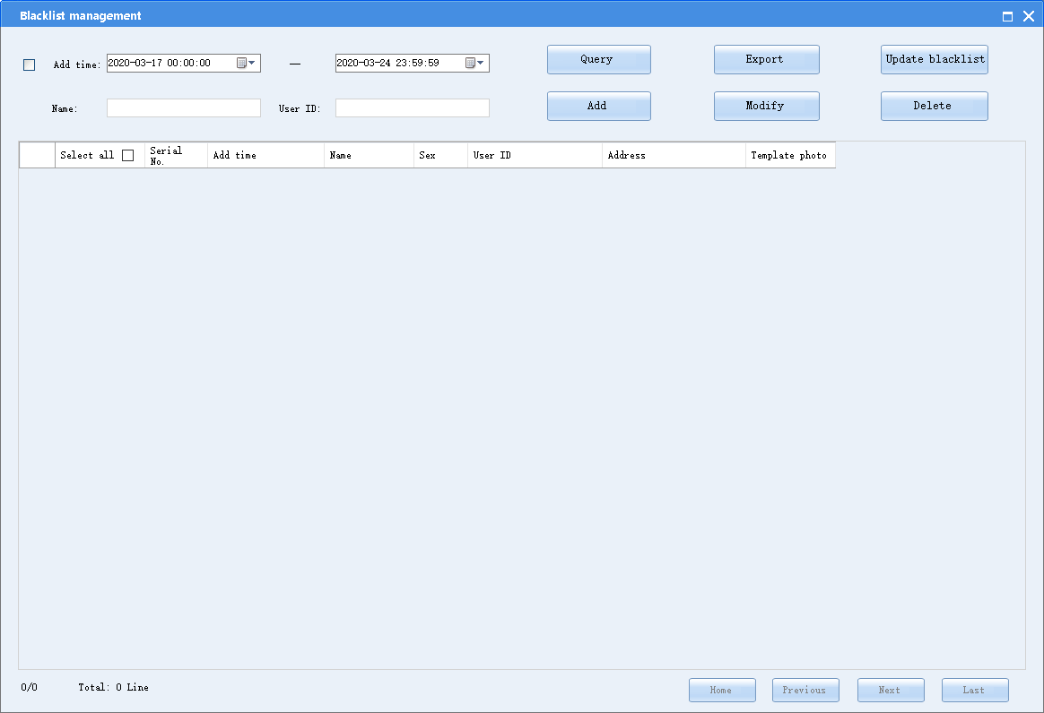
- Querying the blacklist data
To query a blacklist, select the start time and end time, enter the name or identity card, and click Find.
- Adding a blacklist
To add a blacklist, click Add. The page for adding a blacklist is displayed, as shown in the following figure.
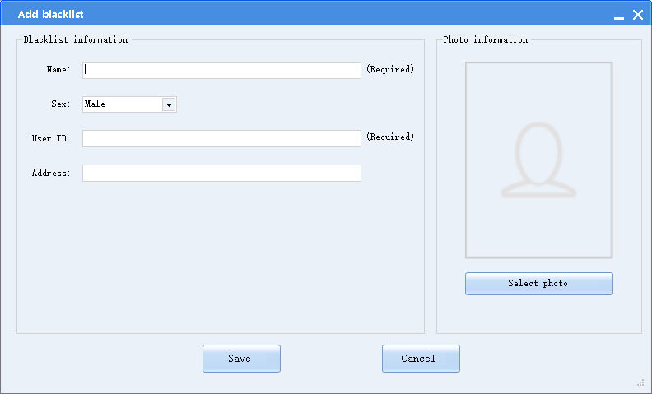
Enter the name, sex, nationality, identity card No., and address, select an existing photo, and click Save.
After the blacklist is added, select the blacklist data, and click Deliver blacklist to deliver the blacklist to all connected equipment.
- Modifying a blacklist
To modify a blacklist, select it and click Modify. It is prohibited to modify the identity card No. on the blacklist.
- Deleting a blacklist
To delete a blacklist, select it and click Delete.
- Exporting a blacklist
To export a blacklist after querying the data, select it and click Export. Select the path for saving the exported blacklist, as shown in the following figure.
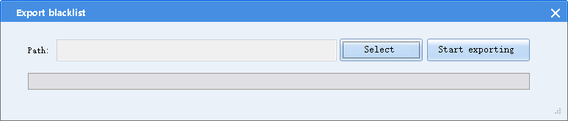

Statistics Query

Querying a Historical Record
Select Historical Record Query in the statistics query menu. The Historical Record Query page is displayed, as shown in the following figure.
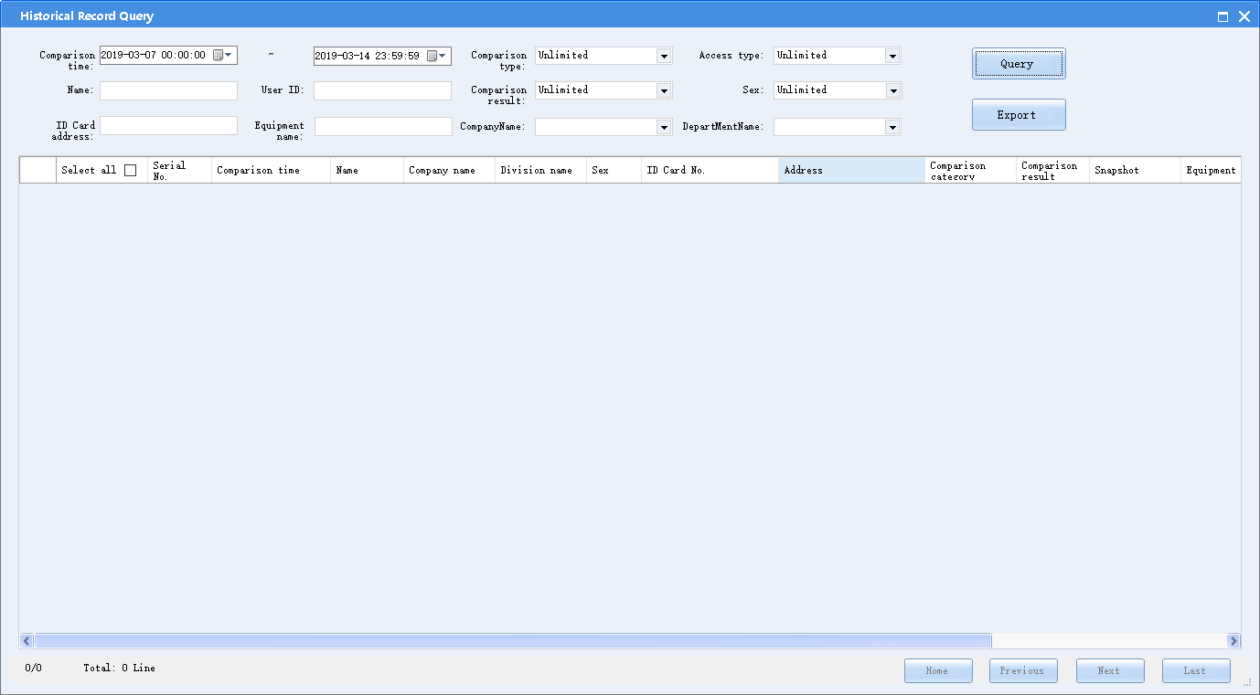
You can set multiple conditions to query and compare historical records. In addition, you can export historical records and convert historical face-and-certificate comparison records into whitelists.
- Querying a historical record
To filter out historical records, enter the start time, end time, comparison type, comparison result, name, identity card No., nationality, sex, address on the identity card, equipment name, and access type.
- Exporting a historical record
To export a historical record to a specified path, click Export and select the path.
- Converting the historical face-and-certificate comparison record into a whitelist
After the historical face-and-certificate comparison record is found according to the search conditions, right-click a record and click Convert into whitelist. Fill in the detailed information to save the record in the whitelist.
If the converted whitelist data already exists in the whitelist library, the system prompts "Whitelist already exists".

Querying Visitor Registration
Select Visitor registration query in the statistics query menu. The Visitor registration query page is displayed, as shown in the following figure.
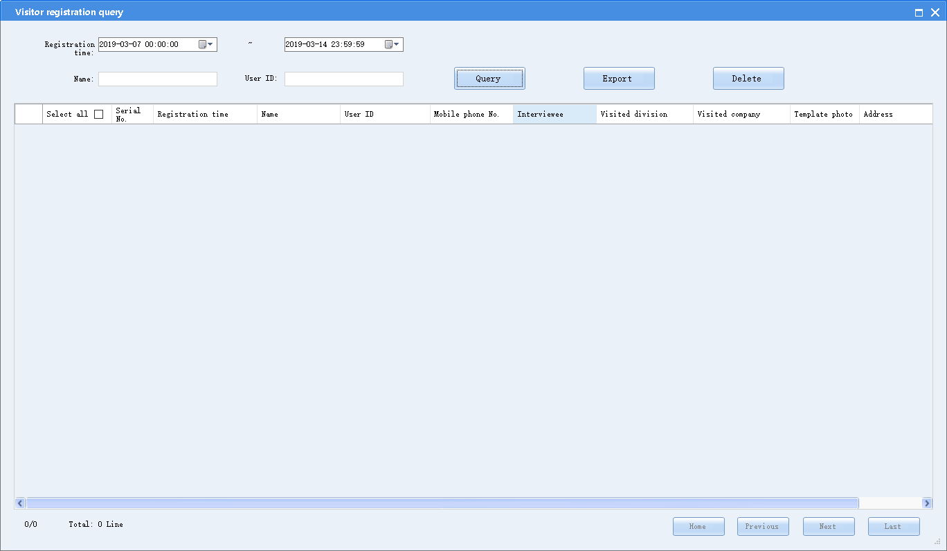
On this page, you can query, add, modify, delete, and export visitor registration data.
- Querying a visitor registration record
To query a visitor registration record, select the start time and end time, enter the name or identity card, and click Find.
- Deleting visitor information
To delete visitor information, select a visitor and click Delete.
- Exporting visitor information
To export visitor information to a specified path, click Export and select a path.

Attendance Statistics Query
Select Attendance Statistics Query in the statistics query menu. The Attendance Statistics Query page is displayed, as shown in the following figure.
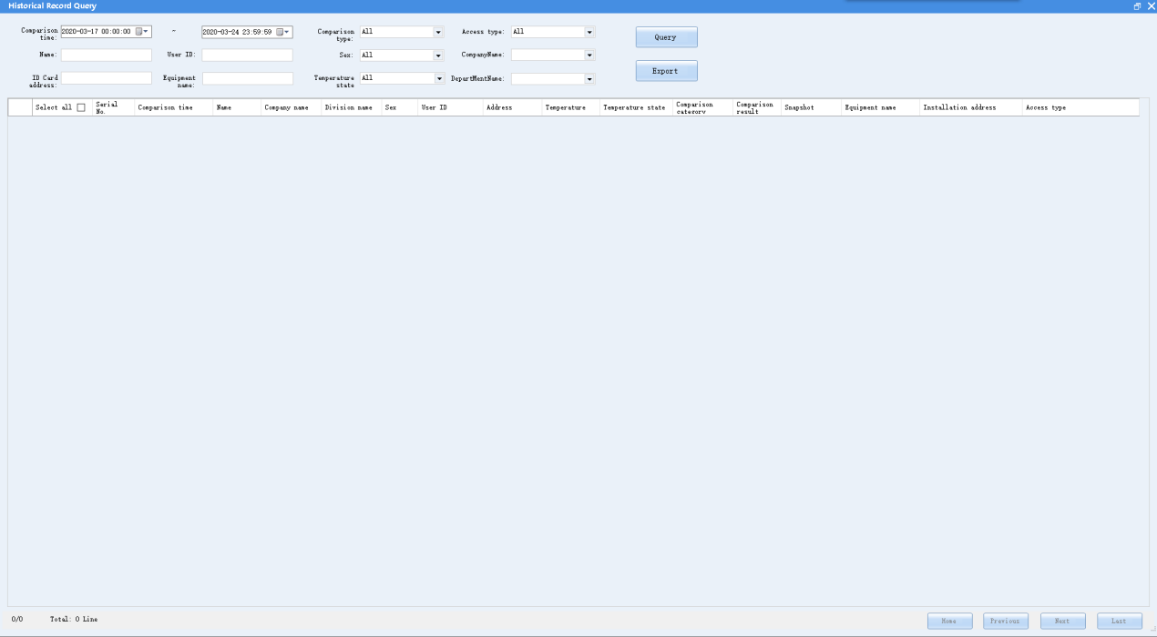
Query the attendance statistics by time and department, and export the statistics into an Excel file.

System Log
Select System Log in the statistics query menu. The Operator authorization group list page is displayed, as shown in the following figure.
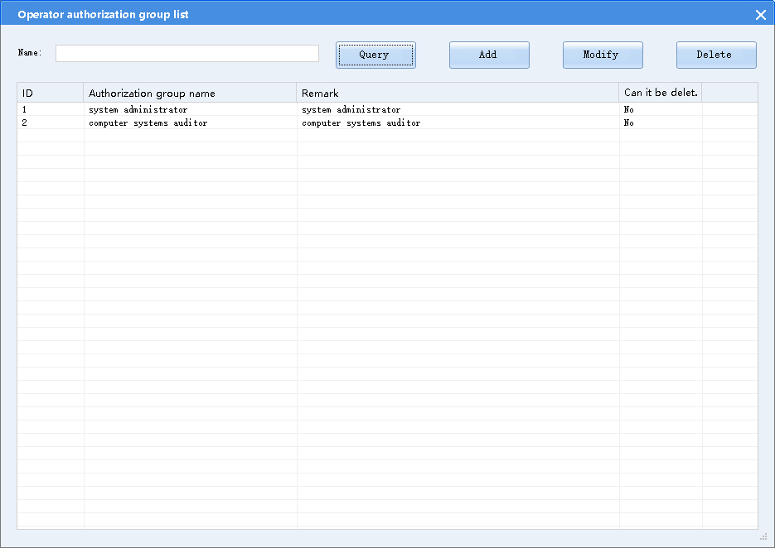
You can query system logs by operation period, operator, and operation type.

Attendance Management

Setting an Attendance Rule
Select Attendance rule in the Attendance Management menu. The Attendance rule page is displayed, as shown in the following figure.
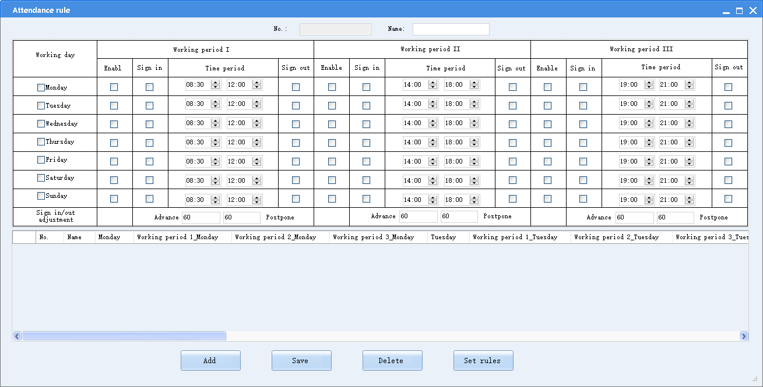
To add an attendance rule, click Add, enter the rule name and content, and click Save.
After the rule is set, you can set the department to which the rule will apply for. Click Set rules. The Select attendance rule page is displayed, as shown in the following figure.
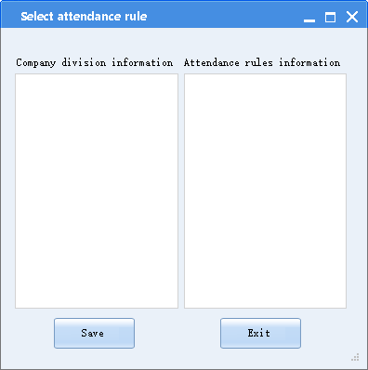
Select a department and the corresponding attendance rule, and click Save.

Holiday Settings
Select Holiday settings in the attendance management menu. The Holiday settings page is displayed, as shown in the following figure.
You can add a holiday. During the holiday period, the system does not measure the attendance.
You can add a workday. During the workday period, the system measures the attendance.
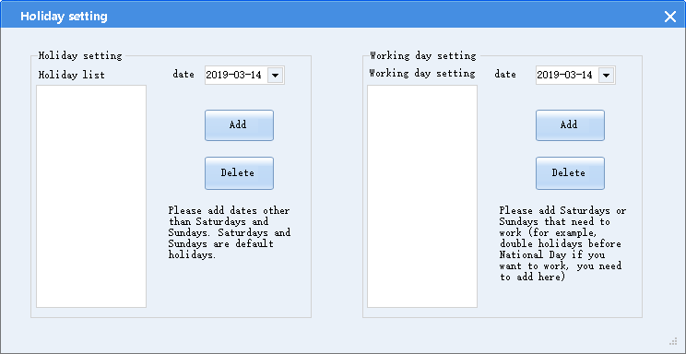

Leave Management
Select Leave management in the attendance management menu. The Leave for business page is displayed, as shown in the following figure.
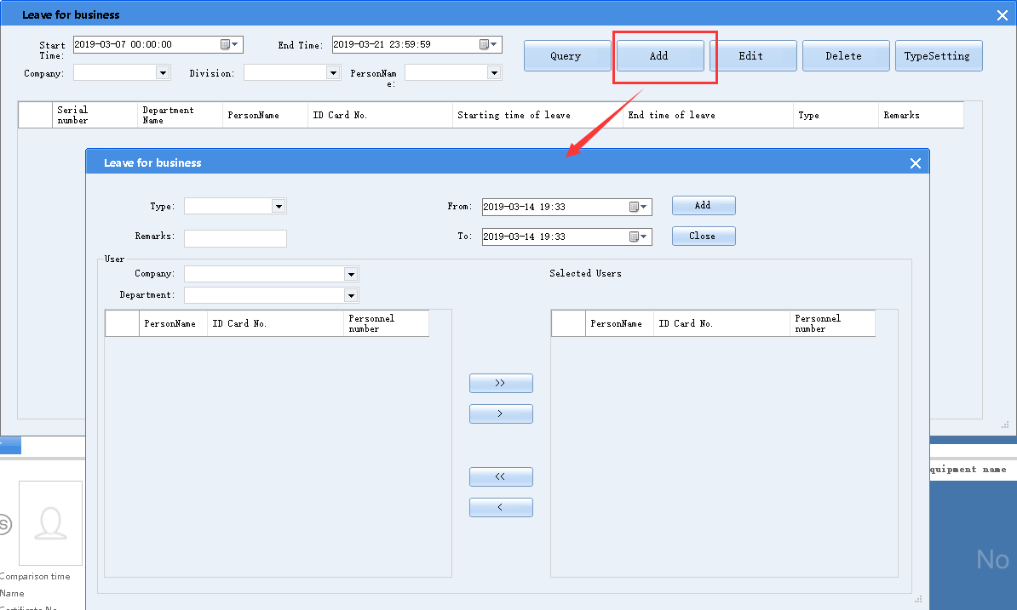
On the Leave for business page, click TypeSetting. The Category Settings dialog box is displayed, as shown in the following figure.
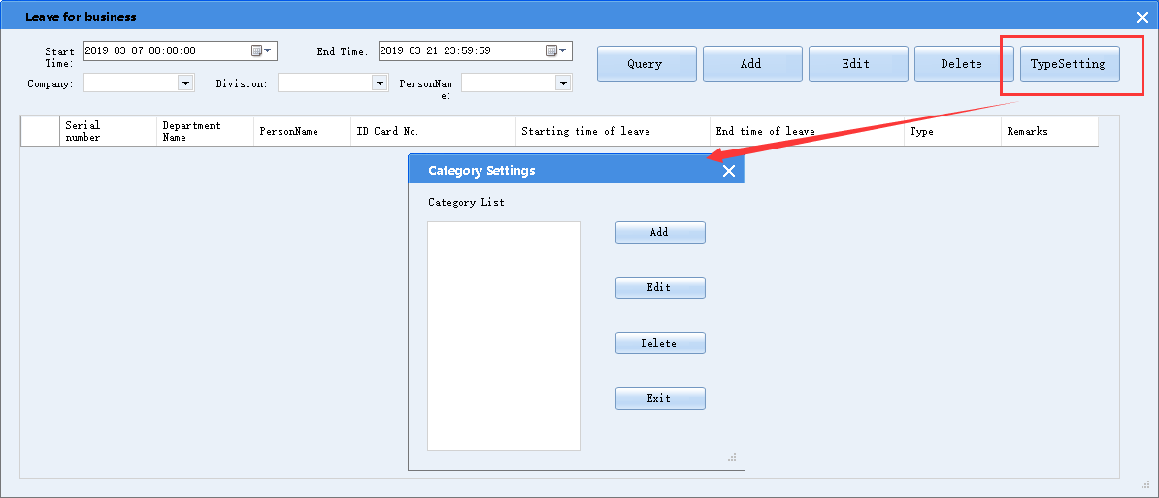
You can add, delete, and modify the category according to actual requirements. To add a category, click Add. Enter the leave type in the Category Name input box, and click Save.

Sign-in Settings
Select Sign-in settings in the attendance management menu. The Sign in page is displayed, on which you can re-sign in or query the re-sign in record.
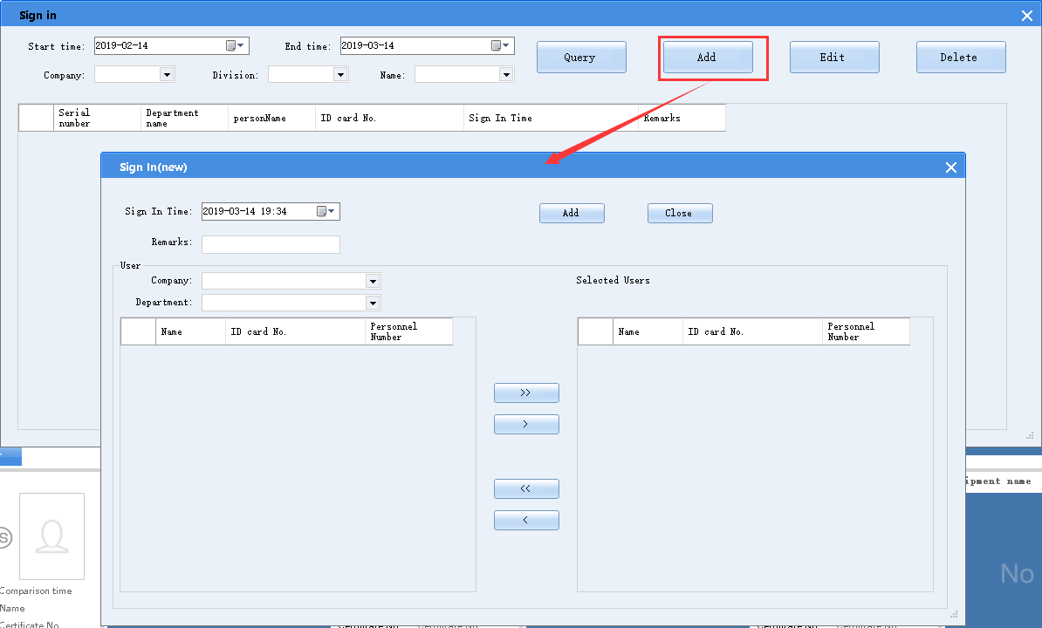

Regular Class Settings
Select Regular Class Setting in the attendance management menu. The Regular Class Setting page is displayed, on which you can set the late arrival and early departure rules.
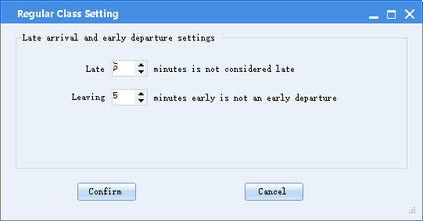

Area Management

Area Settings
Select Area setup in the work site management menu. The Area setup page is displayed, as shown in the following figure.
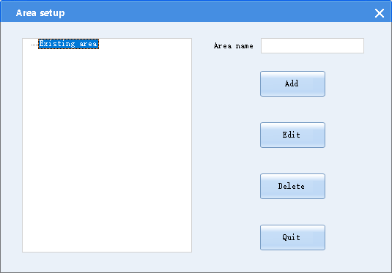
On this page, you can add, modify, or delete an area, set different control cards, and associate an area with different equipment for visitor statistics.

Area Control Card Settings
Select Area Control Card Settings in the area management menu. The Area Control Card Settings page is displayed, as shown in the following figure.
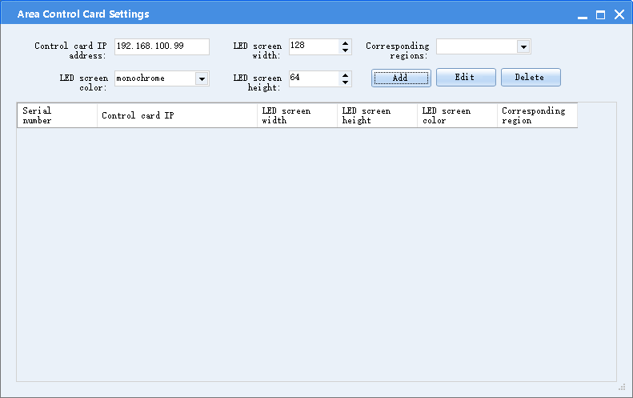
On this page, you can add, modify, or delete a control card, associate different areas with the control card, and set the area information to be displayed on the LED screen controlled by the control card.

Area Device Management
Select Area device Management in the area management menu. The Area device Management page is displayed, as shown in the following figure.
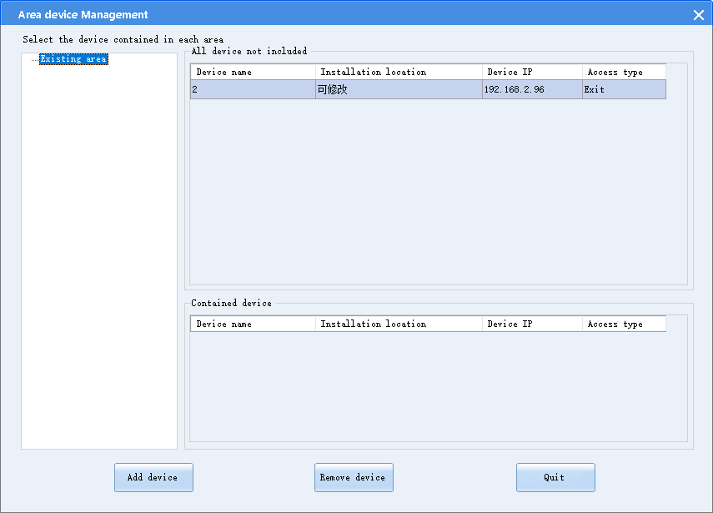
On this page, you can associate different devices with different areas. The visitor statistics will be displayed on the control card associated with an area.

Note
Each device can be associated with only one area.

LED Screen Settings
Select LED screen settings in the area management menu. The LED screen settings page is displayed, as shown in the following figure.
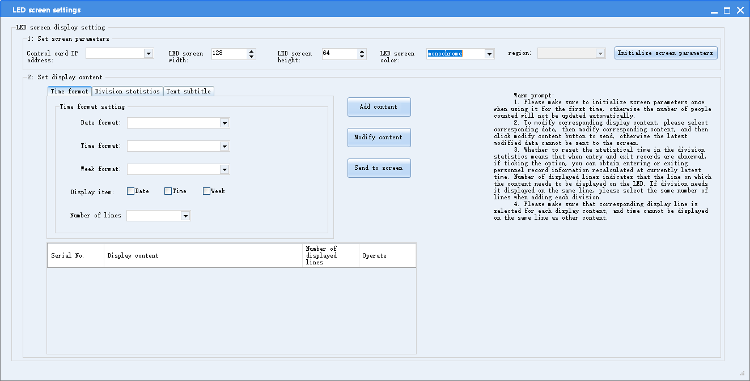
Before using the control card, set the LED screen width and height, and initialize the screen parameters.
- The time format, text subtitle, and division statistics that are displayed in a single line can be customized.
- Different contents can be displayed in different lines by customization.
- The same line can display statistics of multiple divisions.
Time format, text subtitle, and division statistics should be placed in the same line.
After content is added, click Send to screen.

Note
- Time format, text subtitle, and division statistics cannot be displayed in the same line.
- The following content cannot be displayed on the same line simultaneously:
Time format and division statistics, text subtitle and division statistics, and time format and text subtitle
- The same line can display multiple divisions.
- All lines must be within the display area of the LED screen.

System Management

System Settings
Select System setting in the system management menu. The System setting page is displayed, as shown in the following figure.
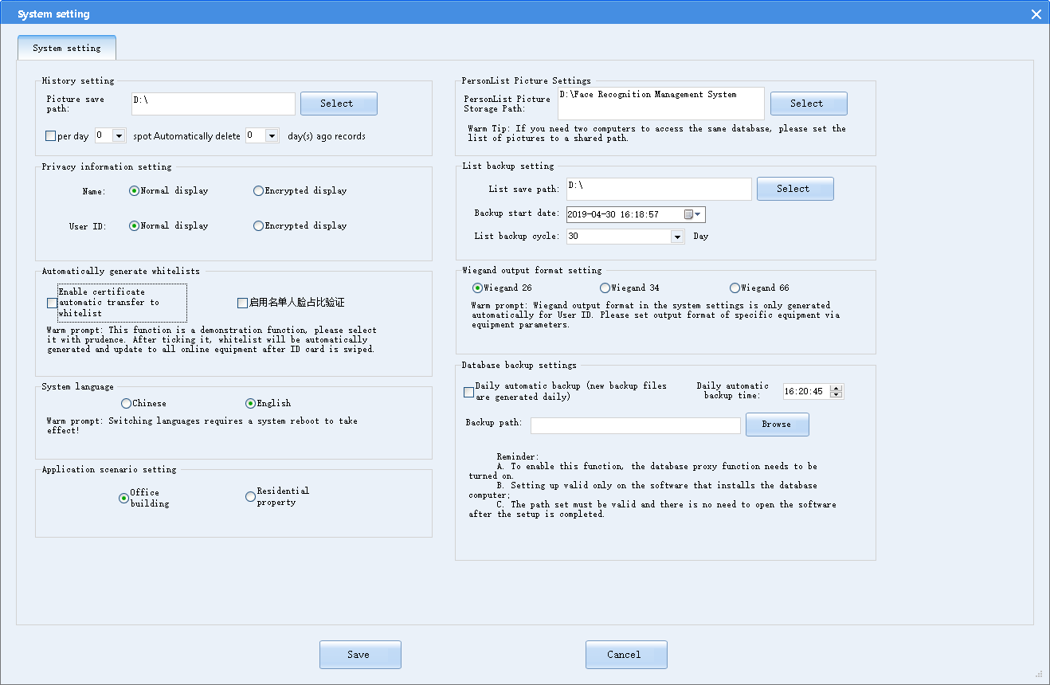
- Picture save path: Specifies the path that saves the photo used for comparison. It is recommended to select a folder for saving photos.
- Storage duration: Specifies the data storage duration and automatic deletion time. When the specified deletion time is due, the system automatically deletes data and stored photos.
- Display mode: Indicates the name and identity card No. display modes on the main UI.
In normal display mode, the main UI displays all names and identity card No.
In encrypted display mode, the main UI displays the encrypted names and first six digits of the identity card No.
- Automatically generate whitelists: When Enable certificate automatic transfer to whitelist is selected, the system automatically transfers visitor data that passes the face-and-certificate comparison to the whitelist.
- Enable face proportion verification: When this option is selected, the proportion of the face recorded into a whitelist must range from 25% to 85%.
- Application scenario setting: Specifies the system application scenario.
- PersonList Picture Settings: Specifies the folder that stores the whitelist/blacklist photos.
- List backup setting: Specifies the automatic whitelist backup period and path for storing the backup list.
- Wiegend output format setting: Specifies the Wiegend output format. By default, the Wiegend 26 mode is adopted. The added whitelist will be displayed and exported according to the specified Wiegend output format.
- Card reader configuration: If the access control adopts the IC mode, a card reader is required. Configure the card reader ESN and set a new card No. for issuing cards upon face recognition.
If the access control does not use the IC mode, it is unnecessary to enable the card reader.
- Database backup settings: Specifies the automatic database backup period and time as well as the backup file storage path.

Database Configuration
Select Database creation tool in the system management menu. The Database creation tool page is displayed, as shown in the following figure.
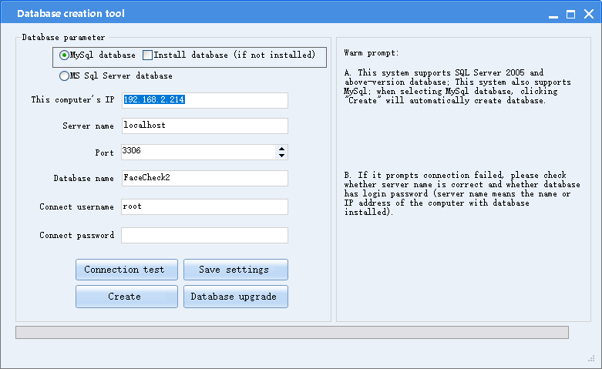
On this page, you can modify the database currently connected to the system. For details, see section 3.2 "Creating a Database."

Department Management
The following figure shows the Department Management page.
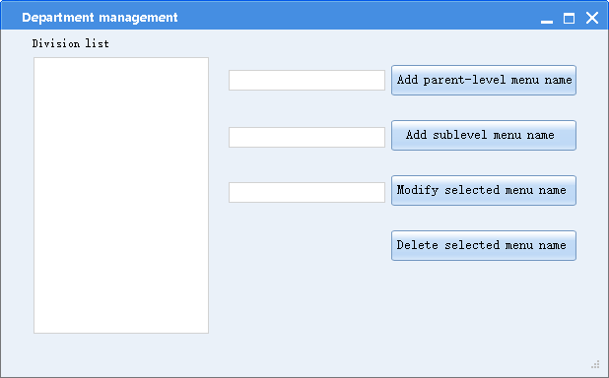

Operator Management
On the Operator management page, you can add, modify, or delete an operation, as shown in the following figure.
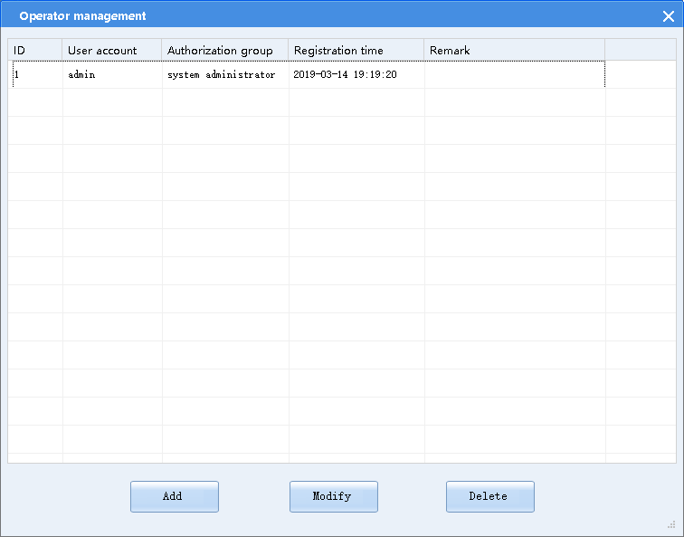
- Adding an operator
Choose System settings > Operator management > Add.
On the Add operator page, enter the user account, authorization group, login password, and click OK.
Note: The user name can contain letters and digits.
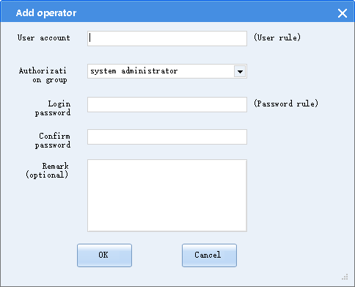
- Modifying an operator
Choose System settings > Operator management > Modify.
On the Operator edit page, modify the user account, authorization group, and login password, and click OK. After modification, use the new information to log in to the system.
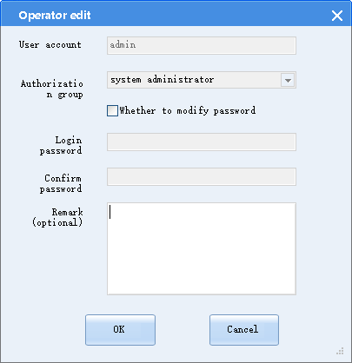
- Deleting an operator
Choose System settings > Operator management > Delete. On the prompted dialog box, click OK.
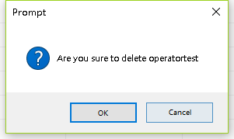

Note
Please properly keep the new user password and changed password.

Operator Authorization Group
The operator authorization group is used to manage permissions of login users. Users can be added to different authorization groups based on function categories. The following figure shows the Operator authorization group list page.
- Add: Creates authorization groups according to different system function categories.
- Modify: Re-allocates system functions to established authorization groups.
- Delete: Deletes established authorization groups.

User Switching
Click the user icon in the upper left corner to switch login users.

About the System
Click About on the main UI to view the latest system version No.

Appendix

Appendix 1: Multi-Client Access
When multiple clients are used simultaneously and access the same database, share the following folders:
- Folder specified in Picture save path
- Folder specified in PersonList Picture Storage Path
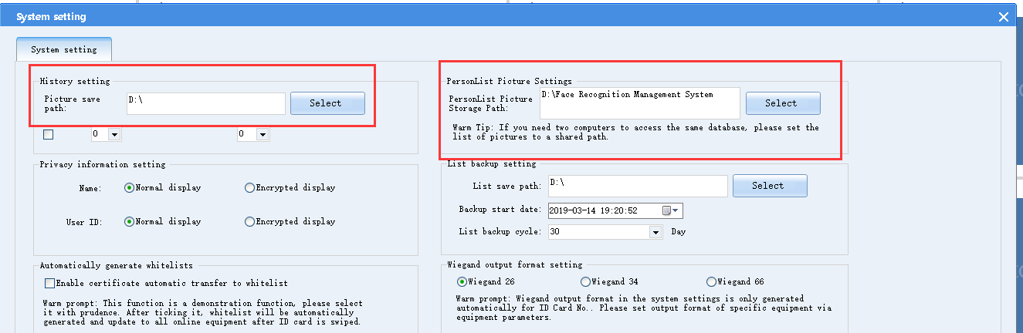

Share the path as follows:
(For the Windows 10 system, right-click a folder and select Grant permissions. For the Windows 7 system, right-click a folder and select Share with. You can add an independent access user.)
After the folder sharing is set, set the photo saving path to a network path on the client with which the folder is shared. The network path must be the same as the shared folder.

Appendix 2: Face Recognition Management System Installation
- Installing the face recognition management system software
Decompress the compressed package of the face recognition management system software. Double-click , and enter the installation page.
Click Next.
Click Install. Wait until the installation is complete. After the installation is complete, the Face Recognition Management System icon and Database Creation Tool icon are automatically created on the desktop.
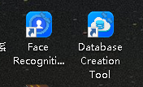
If the shortcut icon is not generated, choose Start > All Programs > Face Recognition Management System. Create a shortcut icon of the program on the desktop.
- Creating a database
Double-click the 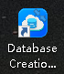 icon to enter the database creation page, as shown in the following figure.
Select the database type. The MySQL database is automatically created upon the first use. Set the database parameters and click Connect test.

After the connection is successfully tested, click Create. A dialog box is displayed, as shown in the following figure.
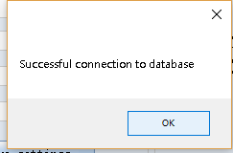

Click Upgrade database. A dialog box is displayed, as shown in the following figure.
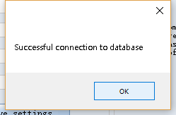

Click Upgrade database. A dialog box is displayed, as shown in the following figure.
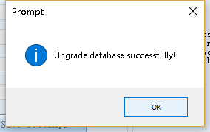

After the database is successfully upgraded, close the database creation tool.

Note
If the database is installed according to the video guide, fill in the local IP address or "." as the server name. The database can be successfully connected without a user name and password.

Appendix 3: Database Installation
1. The SQL Server 2008 R2 database is recommended for the face recognition management system. For details about the installation, see 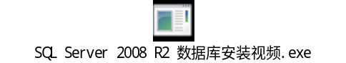.
2. If the local PC does not have the MySQL database, select Install database (if not installed), so that the system automatically installs the MySQL database upon data creation.
It is unnecessary to install the MySQL database in advance. During the database creation, select the Install database (if not installed) option. Then, the system automatically installs the MySQL database upon data creation.

Appendix 4: Mandatory Software Installation for the Face Recognition Management System
The mandatory software of the face recognition management system must be installed. Click Next until the software is completely installed.
For the initial installation, you must install the mandatory software.

Appendix 5: Software installation

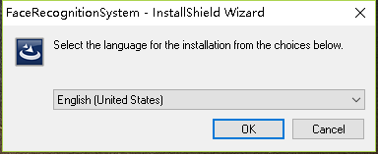
Notes: The computer system language must be English, or the Chinese display will appear in this interface

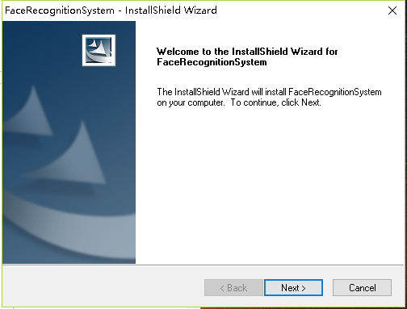
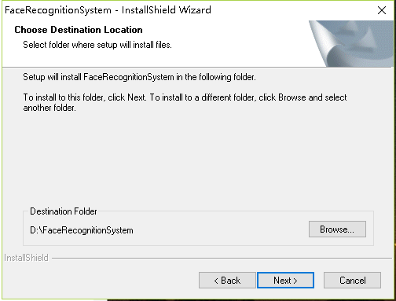
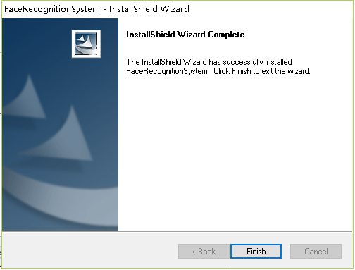

Appendix 6: Software Uninstallation
Method 1: Right-click the face recognition management system on the All Program list to uninstall it.
Method 2: Double-click the software icon to enter the installation management page.
Select Remove and click Next, until the uninstallation is complete.
Method 3: Uninstall the system using the program uninstallation function of the Windows system.

